***AWS CLI***

Using CentOS we shall install the AWS – CLI to access the aws, so we need to follow the following steps to enable it.

* yum update
* yum install awscli
* With the above commands you will install the AWS-CLI, now we need to configure the AWS with your AWS credentials so that whenever you run an AWS command.
* aws configure – this will ask for the details to get the AWS configured by CLI to access the AWS.
* **AWS Access key ID:**
* **AWS Secret Access Key:**
* **Default region name:**
* **Default output:**

The above details you need to update by getting the details from the corresponding IAM user details.

Now let’s see some basic commands on the AWS CLI.

* ***aws ec2 describe-regions --output table***

The above command will give the output as shown below,

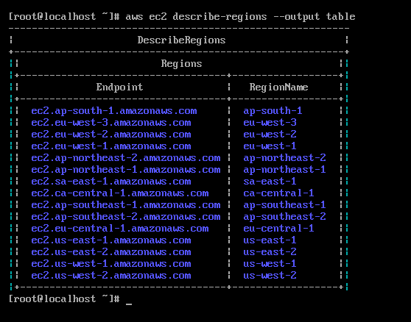

* If you are already having an EC2 instance running then you can use the below command,
* ***aws ec2 describe-instances*** - - this will be the json output of the created instances and its details.
* If you are looking for the commands to use the awscli then please use the below mentioned command,
  + - aws help - - this will populate the commands and its description.
  + Let’s see some sample commands with ***“S3 - Buckets”***
  + ***aws s3 ls –*** gives the list of buckets present in the S3 service.
  + ***aws s3 ls s3:***//<bucketname> -- will give the results of the content present in the bucket(i.e. creation date, size of the content file, name of the content)
  + ***aws s3 mb s3://<***bucketname> -- this command will create a bucket under the s3 services.
  + ***aws s3 rb s3://<bucketname> --*** this command will help us to remove the created bucket for the list of buckets present in the s3 services.
  + ***aws s3 rm s3:***//<bucketname>/<filename> -- this will help us to remove the content of the bucket which we created using the AWS s3 services.
  + ***aws s3 cp s3:***//<bucketname1>/<filename> s3://<bucketname2> -- this will help us to move the file present in the bucketname1 to bucketname2.

**https://vnextcoder.wordpress.com/2016/10/25/part-3-storing-jenkins-output-to-aws-s3-bucket/**

In this task we will see how to configure Jenkins with AWS and push the built artifact to the S3bucket,

* Here we need to configure the AWS S3 with Jenkins
* Install the plugin called “Post Build Task” – which will help us to move the built artifact to an S3 bucket in the AWS.
* For this task we need configure the AWS in the Jenkins,
  + - for this please go to Configure systems option on Jenkins (Manage Jenkins)
    - Under the Artifact Management for Builds 🡪 under this section we need to select Amazon S3 and this will be enabled when we install the S3 plugins on Jenkins.
    - Under this we need to configure the AWS to enable this moving of artifacts to S3 buckets.
* Now let’s begin the task of uploading the artifacts from Jenkins to S3 Buckets.
* First create the S3 Bucket with the desired name. Give the public access permissions.
* Now we need to create an IAM user with the permissions to access the S3 bucket which has been created in the previous step.
* Now once the IAM user is created please have the Access Key and Secret Key downloaded and kept handy for future usage.
  + - To get the access key and secret key just follow steps while the user is created and keep them handy.
  + Now we need to create a Policy for this task specific,
    - Under the IAM console, go to Create Policy 🡪 give a name for this policy and give the below mentioned rules for this policy,

{

"Version": "2012-10-17",

"Statement": [

{

"Action": [

"s3:ListAllMyBuckets"

],

"Effect": "Allow",

"Resource": "arn:aws:s3:::*"

},

{

"Action": "s3:*",

"Effect": "Allow",

"Resource": [

"arn:aws:s3:::<yourbucketname>",

"arn:aws:s3::: <yourbucketname>/*"

]

}

]

}

* Once this policy has been updated with your bucket name, just go to attach entity section and attach the above policy so that we say that the bucket access is granted.
* Now we need to work on the Jenkins configuration,
  + - Make sure we install the S3 Plugin in the manage Jenkins 🡪 manage plugins section.
  + Now we need to configure the S3 Profile,
    - Manage Jenkins 🡪 Configure system 🡪 Look for Amazon S3 Profiles 🡪 under this section you need to give the access key, Secret Key, Profile name.
    - With the above step you declare that IAM profile has been configured to access the S3 buckets.
  + Now we need to Configure the Post Build Actions on the Jenkins, in order to push the Artifacts, once the build is successful, For this we need to follow the below steps,
    - Select the Publish artifacts to S3 Bucket option under the Post Build Actions section.
    - Make sure you fill the details appropriate.
* Once you configure the Post Build Actions in Jenkins, Now get ready to trigger a build for the Jenkins Job which we configured for S3 Bucket updating with the Build Artifacts.
* Once the Build is Success Just GO to the AWS S3 Console by using the below URL:
  + - <https://console.aws.amazon.com/s3/>
    - Check the S3 Bucket which we configured for this task, It will be filled with the Build Artifacts pushed from the Jenkins Build Job.

**Note: Please make sure you follow the exact steps and values in order to complete the task of updating the S3 Buckets with the build Artifacts.**